**WEEK 6**

## ReactJS Hands-on Assessment

### Task 1: Create React App 'myfirstreact'

Objective: Create a simple React app that prints a heading.

Steps:

1. Install Node.js and npm from: https://nodejs.org/en/download/

2. Open VS Code Terminal and run:

npx create-react-app myfirstreact

cd myfirstreact

code .

3. Open src/App.js and replace content with:

import React from 'react';

function App() {

return (

<div>

<h1>Welcome to the first session of React</h1>

</div>

);

}

export default App;

4. Run the application:

npm start

### OUTPUT:

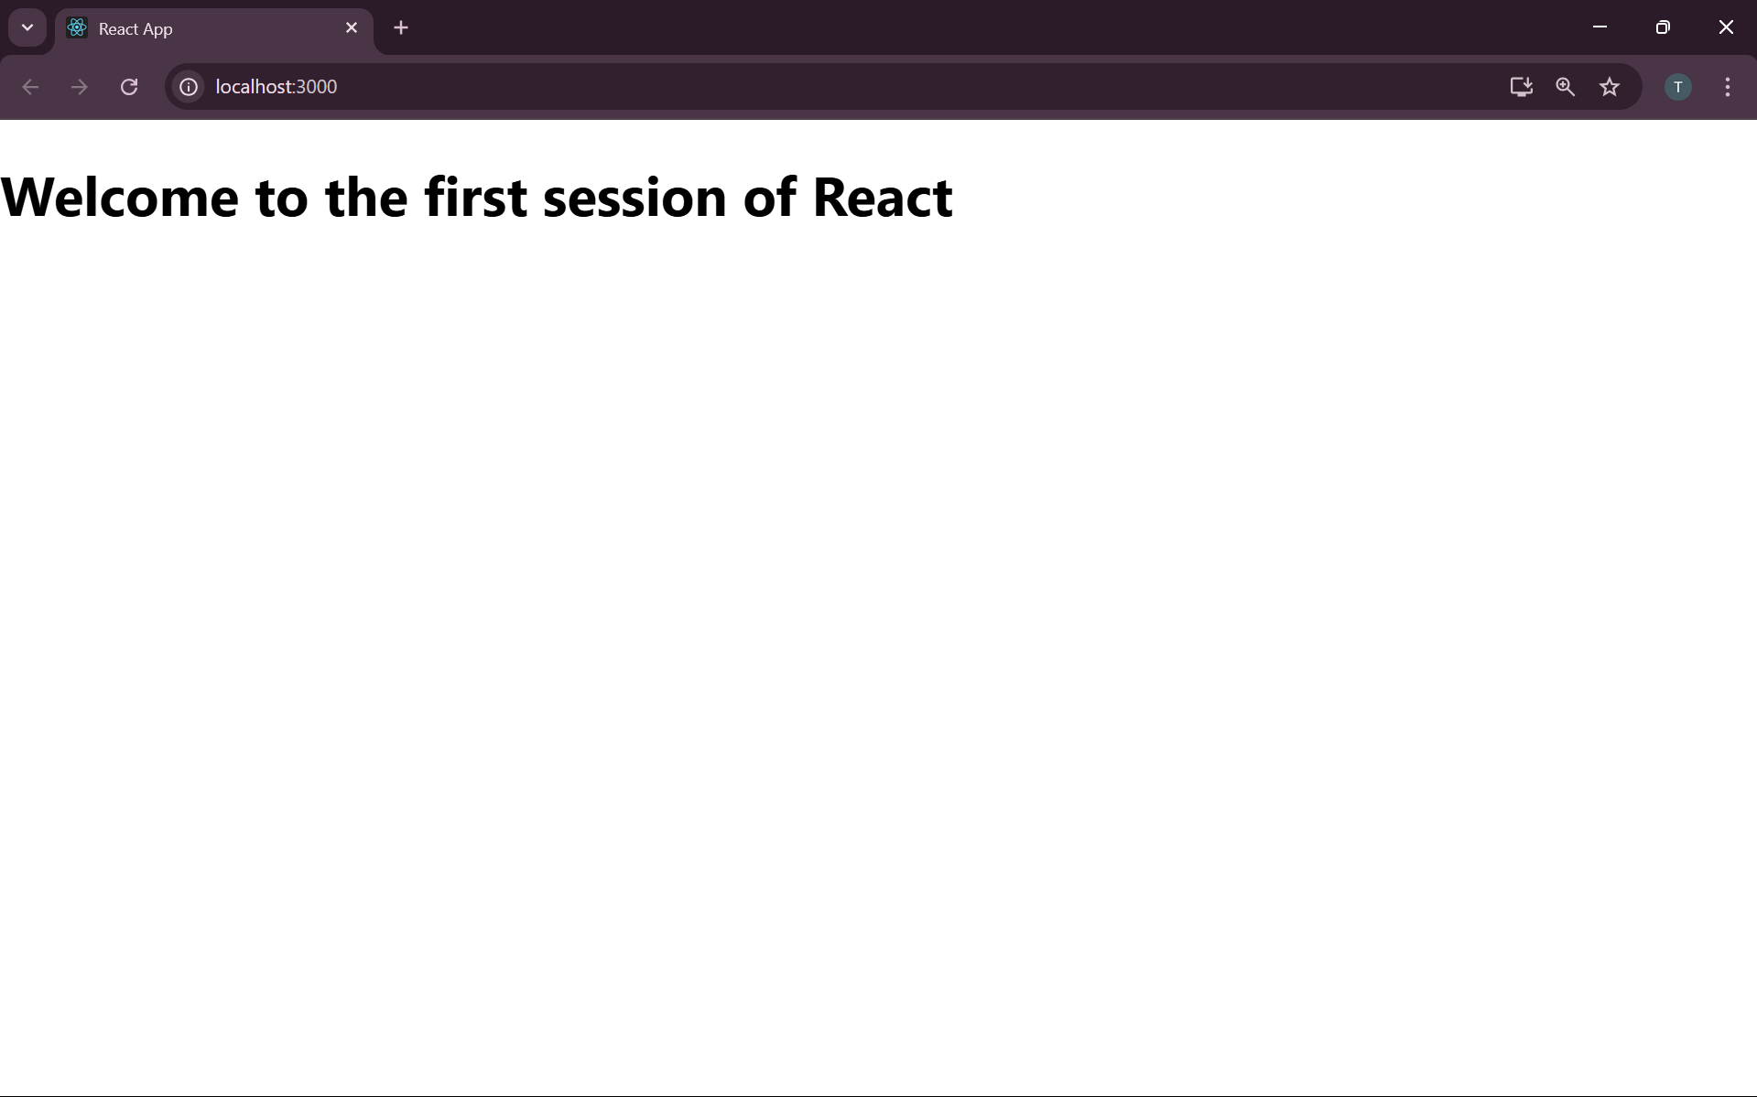

### Task 2: StudentApp with Class Components

Objective: Display Home, About, and Contact pages using class components.

Steps:

1. Create project:

npx create-react-app studentapp

cd studentapp

code .

2. Under src, create folder Components and files Home.js, About.js, Contact.js

Example: Home.js

import React from 'react';

class Home extends React.Component {

render() {

return <h2>Welcome to the Home page of Student Management Portal</h2>;

}

}

export default Home;

3. Repeat above for About.js and Contact.js with respective messages.

4. Update App.js:

import React from 'react';

import Home from './Components/Home';

import About from './Components/About';

import Contact from './Components/Contact';

function App() {

return (

<div>

<Home />

<About />

<Contact />

</div>

);

}

export default App;

5. Run the application:

npm start

### OUTPUT

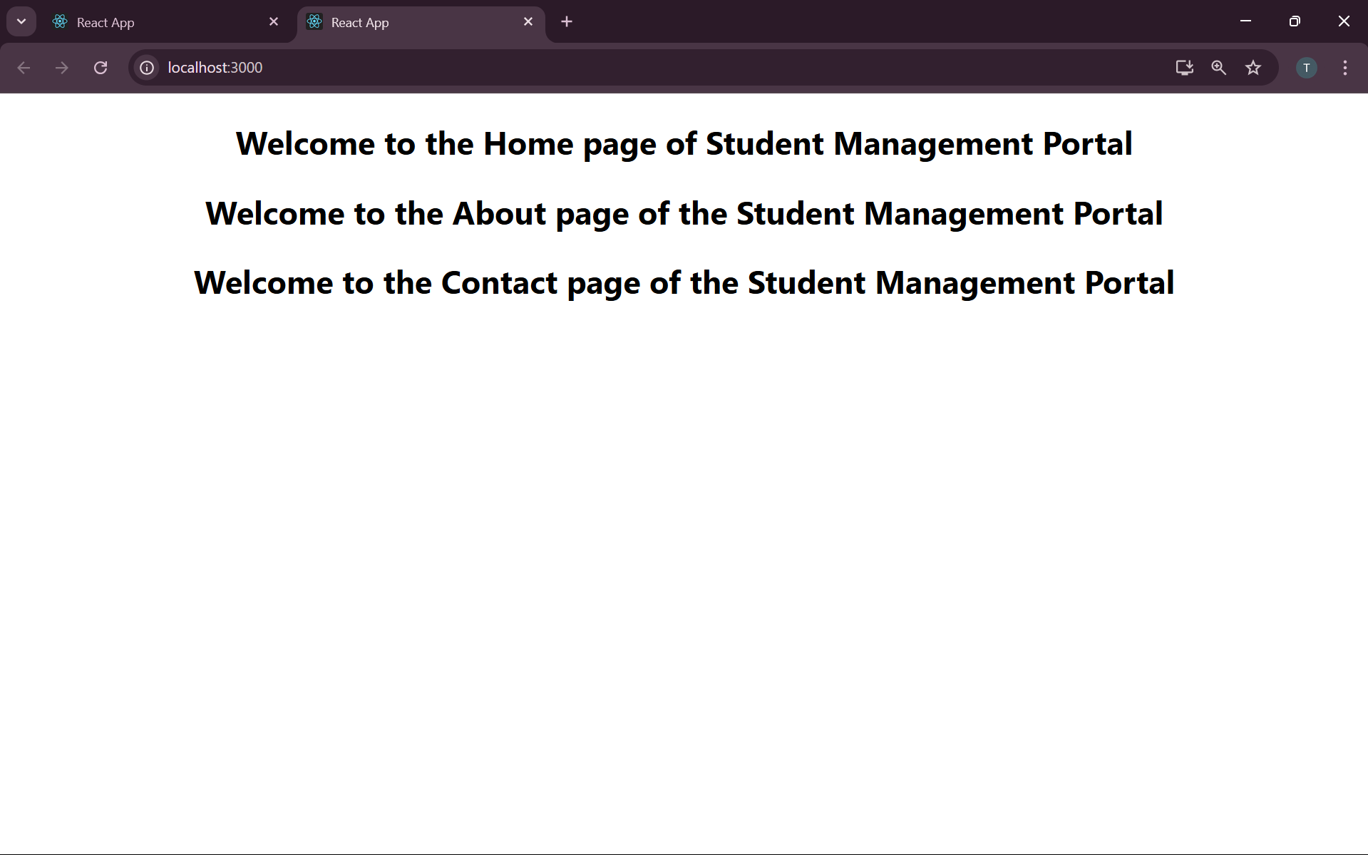

### Task 3: Score Calculator App

Objective: Create a function component to calculate and display average score.

Steps:

1. Create project:

npx create-react-app scorecalculatorapp

cd scorecalculatorapp

code .

2. Create src/Components/CalculateScore.js

import React from 'react';

import '../Stylesheets/mystyle.css';

function CalculateScore() {

const name = "Riya";

const school = "St. Xavier's";

const total = 470;

const goal = 500;

const average = (total / goal) * 100;

return (

<div className="score-card">

<h2>Student Score Calculator</h2>

<p><strong>Name:</strong> {name}</p>

<p><strong>School:</strong> {school}</p>

<p><strong>Total:</strong> {total}</p>

<p><strong>Goal:</strong> {goal}</p>

<p><strong>Average:</strong> {average.toFixed(2)}%</p>

</div>

);

}

export default CalculateScore;

3. Create mystyle.css in Stylesheets folder:

.score-card {

width: 400px;

margin: 30px auto;

padding: 20px;

border: 2px solid #3498db;

border-radius: 10px;

box-shadow: 0px 4px 8px rgba(0,0,0,0.1);

font-family: Arial;

}

4. Import and use component in App.js

5. Run the application:

npm start

### OUTPUT:

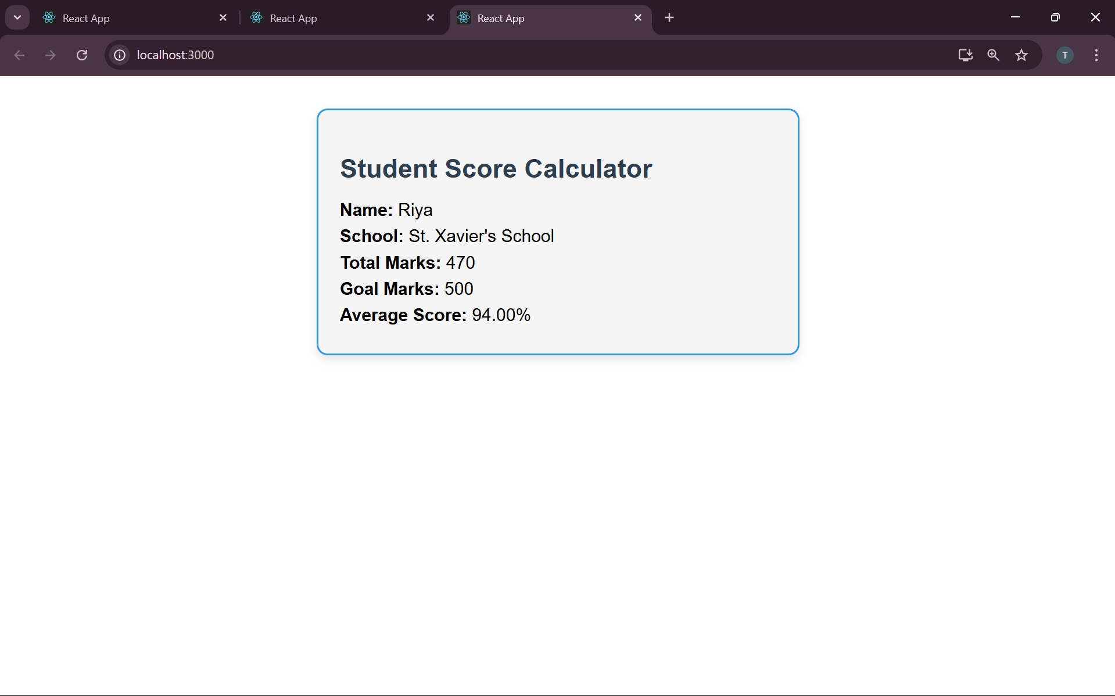

### Task 4: BlogApp with Lifecycle Methods

Objective: Use componentDidMount() to fetch posts and componentDidCatch() to handle errors.

Steps:

1. Create project:

npx create-react-app blogapp

cd blogapp

code .

2. Create Post.js:

import React from 'react';

class Post extends React.Component {

render() {

return (

<div>

<h3>{this.props.title}</h3>

<p>{this.props.body}</p>

</div>

);

}

}

export default Post;

3. Create Posts.js:

import React from 'react';

import Post from './Post';

class Posts extends React.Component {

constructor() {

super();

this.state = { posts: [], hasError: false };

}

componentDidMount() {

this.loadPosts();

}

loadPosts() {

fetch('https://jsonplaceholder.typicode.com/posts')

.then(response => response.json())

.then(data => this.setState({ posts: data }))

.catch(() => this.setState({ hasError: true }));

}

componentDidCatch() {

alert("An error occurred");

}

render() {

if (this.state.hasError) return <h2>Error loading posts</h2>;

return (

<div>

<h1>Blog Posts</h1>

{this.state.posts.slice(0, 10).map(post => (

<Post key={post.id} title={post.title} body={post.body} />

))}

</div>

);

}

}

export default Posts;

4. Update App.js to import and use <Posts />

5. Run the application:

npm start

### OUTPUT:

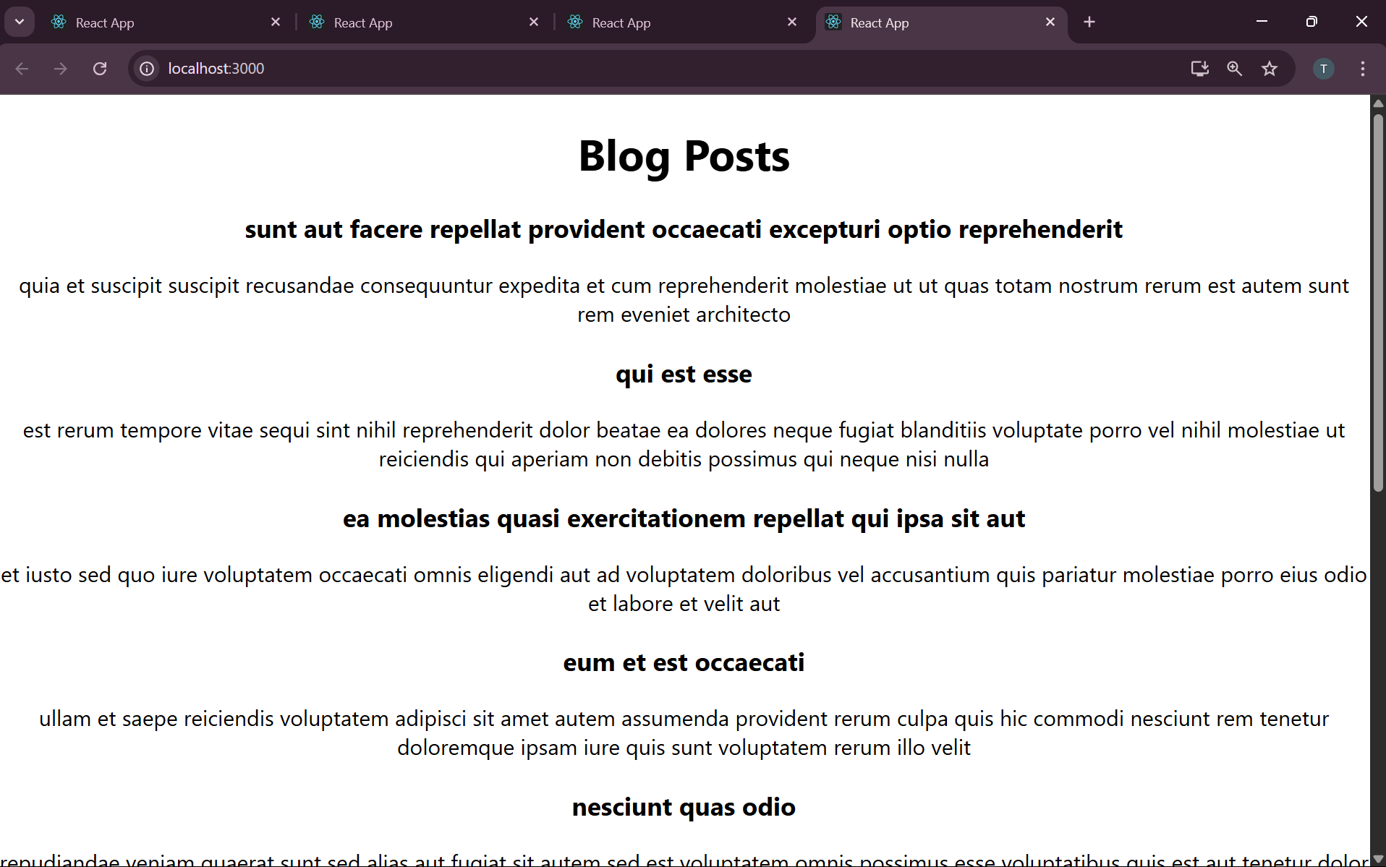

### Task 5: Style Cohort Cards using CSS Modules

Objective: Style cards using CSS Modules and inline styles.

Steps:

1. Create project:

npx create-react-app cohortstracker

cd cohortstracker

code .

2. Create src/components/CohortDetails.js

import React from 'react';

import styles from './CohortDetails.module.css';

function CohortDetails({ cohort }) {

const titleStyle = { color: cohort.status.toLowerCase() === 'ongoing' ? 'green' : 'blue' };

return (

<div className={styles.box}>

<h3 style={titleStyle}>{cohort.name}</h3>

<dl>

<dt>Started On</dt><dd>{cohort.started}</dd>

<dt>Current Status</dt><dd>{cohort.status}</dd>

<dt>Coach</dt><dd>{cohort.coach}</dd>

<dt>Trainer</dt><dd>{cohort.trainer}</dd>

</dl>

</div>

);

}

export default CohortDetails;

3. Create CohortDetails.module.css:

.box {

width: 300px;

display: inline-block;

margin: 10px;

padding: 10px 20px;

border: 1px solid black;

border-radius: 10px;

}

dt {

font-weight: 500;

}

4. Add multiple cohort data in App.js and render using map and <CohortDetails />

5. Run the application:

npm start

### OUTPUT:

